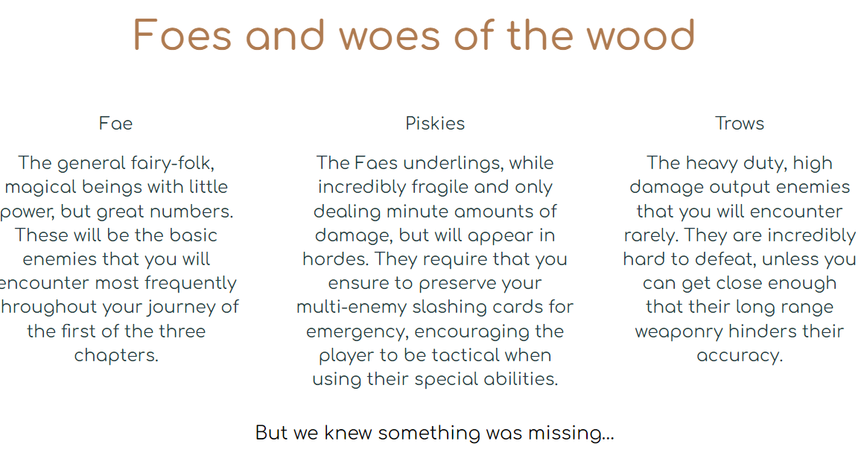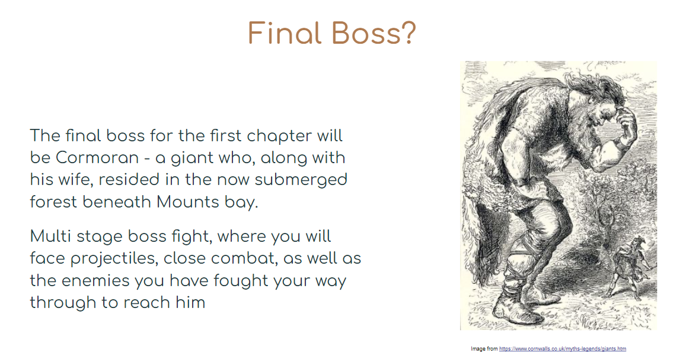

Piskies:

* Spawn in groups and can spawn in any room difficulty
* Low health pool
* No resistance to knockback to make it easier to manage large groups of them
* Will charge and attempt to swarm the player when spotted
* Deal very low damage that stacks up quickly

Trows:

* Attacks the player by firing projectiles at them from a distance
* High health pool
* If the player gets too close they will attempt to run away to put some distance between them
* Briefly stunned by melee attacks to allow the player to stop them from running away
* Spawns in low numbers and only in certain room difficulties (e.g medium - hard)

Fae:

* Moderate health pool
* Attacks with a weak projectile if the player is too far away
* Will attempt to move in and attack the player if they get too close
* Spawns in moderate numbers and can spawn in all room difficulties